

**Experiment No.**

**2**

**Title:**

Understanding F

ile

S

ystem of Linux

I

mplementation of Basic Linux Commands

**Batch: B2** **Roll No: 16010420117** **Experiment No: 2**

**Aim:** Understanding Linux File system and executing basic commands in Linux

________________________________________________________________________

**Resources needed:**  Any Open Source OS/CoCalc Linux terminal online

________________________________________________________________________

**Theory:**

**Pre lab/Prior concepts:**

**File** **-system management:**

The file-system is the way an operating system manages all the files to be stored on the external storage - binaries, images, etc. Linux uses an advanced version of the Extended File -system from Unix, called ext2.

An important feature of the ext2 file-system is that it treats everything as files - directories are also represented as files containing pointers to other files. This does not stop only at directories, even the hardware can be addressed as files under the standard directory /dev.

ne drawback in Linux has been the susceptibility of ext2 to damages due to power failures. But there has been significant development to rectify this shortcoming through the introduction of journaling file-systems like reiserfs, ext3. A journaling file-system has the inherent capability to be recovered to a stable state in case of crashed due to power failures.

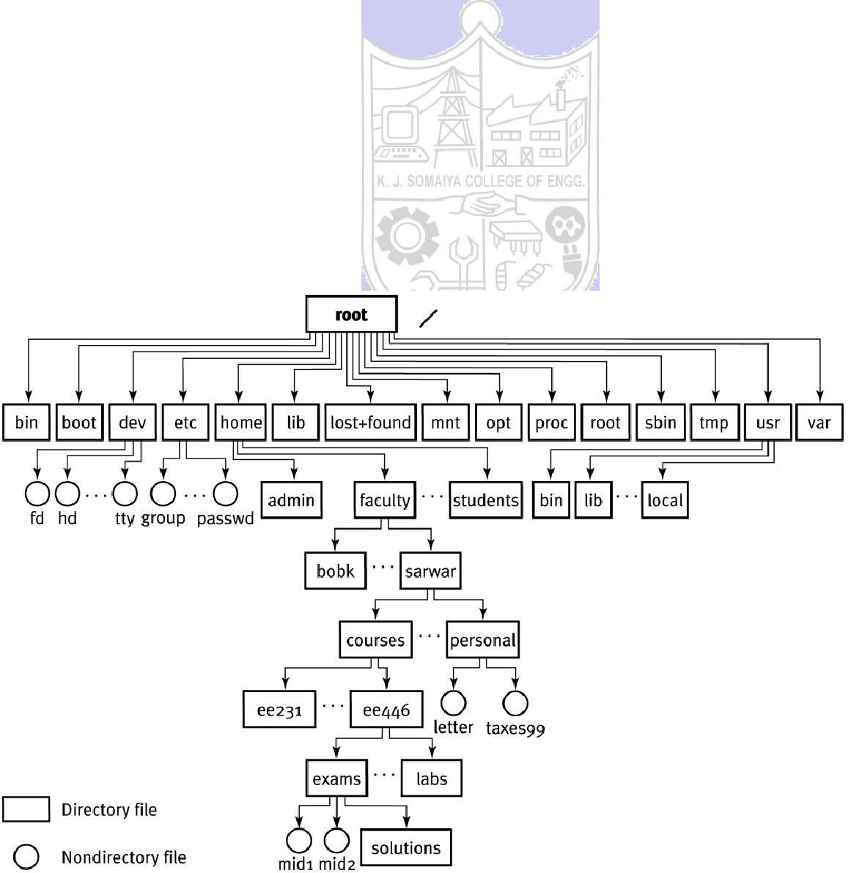

**Directories**

In Linux, different partitions need not be assigned special names to access them. This is

because Linux uses a standard directory structure to

take care of all partitions. This

structure ensures that a particular file for a particular program will almost always be

present at the same place on any machine running Linux.

The figure above show the hierarchical organization of directories created on the filesystem by default, and which are considered to be standard for all installations. Let us take a look at some of the more important ones.

 /dev is the directory through which all the devices on the machine are accessible as

  files. These include the serial terminals (COM ports), modem, mouse, sound card     ... everything!  

 /var contains most of the "variable" data such as mails, log files, databases, etc.  

 

 /usr is where almost all the packages get installed. Discounting /mnt, it is the largest directory on the hard-disk. This directory itself has a pretty complicated sub-directory system used by the packages.  

 

 /etc contains all the configuration files, used by the operating system itself as well

  as various packages installed on the system.  

 /home contains the home directories for all the users created on the system.  

 

 /mnt is conventionally used as the base for all directories which are not part of the standard directory hierarchy. It is most commonly used to mount the cd-rom drives, floppy drives, non-Linux partitions, etc.  

 

 /root is the home directory of the privileged user or the system administrator, called "root".  

In Linux there are different commands available to perform file operations like create, edit, copy, rename and move file.

We can assign read, write, and execute permissions to file. Every file in Linux has a list of permissions attached to it, that specifies the kind of access that different users have to that file. The file permissions are also called its access modes.

The very first column in the above output defines the access modes for the file. Their meaning will become apparent when we look at the way access modes are represented. Thes e can be expressed as either octal numbers or mnemonics.

**Linux commands for file handling:**

File handling commands include commands for creating files/directories, navigating through file system.

**Commands to create a file**

**touch:** creates one or more empty file(s).

**syntax:**

touch filename1 [filename2] [filename3]

**cat:** creates/displays file

**syntax:**

cat [options] [filename]

→

cat > [filename] To create a file

→

cat [filename] To view a file

→

cat >> [filename] To append text to a file

**mkdir :** Make directory (or) To create a directory

**Syntax :**

mkdir [options] [dirname]

mkdir –p /home/abc creates directory with subdirectories

mkdir –m 777 ~/data creates data directory in home and assigns read, write, execute

permissions to it

**rmdir:** Remove an empty directory. If you want to remove a directory with files in it type

" rm -R directory"

**Syntax:**

rmdir dirname

This will only remove directory if it's empty otherwise it will exit with an error message.

**pwd:** Print working directory. Print the absolute (complete) path to the directory the useris currently in. **Syntax**:pwd



You can use ls

-

d to show directories that match an exact string, or use standard wildcards.

Type " ls

-

d */" to list all subdirectories of the current directory. Depending on the setup of

your aliases you may simply be able to type lsd as the equivalent t

o ls

-

d */ .

Examples for ls

-

d :

ls

-

d

Lists all subdirectories of current directory.

This will tell you the full path to the directory you are in, for example it may output "/usr/local/bin" if you are currently in that directory.

**cd:**  Change directory. Use " cd .." to go up one directory.

One dot '.' represents the current directory while two dots '..' represent the parent directory. " cd -" will return you to the previous directory (a bit like an "undo").You can also use cd absolute path or cd relative path

**ls :**  List the Files and Directories within the current directory.

**Syntax:**

ls [options] Options:

-l List file with permission. a List hidden file.

-i List files and inode number.

-R List directories , sub directories and their contents.

ls -options string

This lists files using a certain string. The string can contain standard wildcards to list multiple files

ls -d string*

Lists directories that start with "string".

ls -d /usr/*/*/doc

Lists all directories that are two levels below the /usr/ directory

**chmod:** change mode(permissions) for file/directory

Chmod [rwxrwxrwx]/[421412421] filename

**rm:**Remove/delete a file(s) or directories(s). You can use standard wildcards with thiscommand

**Syntax:**

rm -options file_or_folder

You can of course use standard wildcards to delete multiple files or multiple directories and files.

Use the -R or -r option to remove recursively, this removes everything within subdirectories. Also try the -f option to force removal (useful when you don't want to be prompted).

**mv:**Move a file or a directory to a new location or rename a file/directory.Rename example:

mv filename1 filename2 Renames filename1 to filename2.

To move a file or directory, simply type: mv original_file_or_folder new location

Note that this command can use standard wildcards to move files (not for renaming).

Move and rename

Note that you can also move and rename a file in a single command. The difference is with the destination (right hand side) you change the filename to the new name of the file.

For example typing: mv /etc/configuration.txt /home/joe/backupconfig

This would move the file "configuration.txt" to /home/joe/ and rename it "backupconfig"

**cp:**Copy a file. Has a number of useful options, such as -R (or -r ) which recursivelycopies director ies and subdirectories.

Syntax: cp -options file_or_files new_location

Examples:

cp file1 file2

Simply copy file1 to file2 (in the same directory).

cp /tmp/file1 ~/file2 /mnt/win_c

**find:** The following examples illustrate typical uses of the command  [find](http://linux.about.com/od/commands/l/blcmdl1_find.htm) forfinding files on a computer.

find / -name game

Looks for a file named "game" starting at the root directory (searching all directories including mounted filesystems). The `-name' option makes the search case sensitive.

You can use the `-iname' option to find something regardless of case. find /home -user joe

Find every file under the directory /home owned by the user joe

There are other commands to locate file like locate, whereis, which, whatis etc.

**User administration:**

Linux is a true multiuser environment. This means that the system can support different users with different privileges. Each user has access to a predefined set of system services and his/her own private data. The private data in turn can be shared with other users by granting access privileges to them. All the privilege checking is done with the help of user accounts maintained by the system. Linux provides a number of commands that can be used to create and manage user accounts. These are supported by a number of files and directories under /etc that are used to hold information about the users. The facilities provided can be broadly classified into two categories - user management and group management.

**User accounts**

Traditionally, the information regarding the users is placed in a file called /etc/passwd. This contains the login name, full name, home directory and other info in a standard format. It may also contain the encrypted password used by the user, hence the name of the file. But nowadays, better ways for user authentication are used, which store the password elsewhere.

**Superuser Account**

By default, every Linux installation has a specially privileged account called the root or superuser. This user has complete access to all the services and resources present on the system. The account is normally owned by the system administrator, and used to carry out special task that require special privileges not available to normal accounts. A person who logs in as root can modify any file on the entire system irrespective of the actual owner of the file and run any program anywhere on the system. As such, it is the most powerful account and has to be used with caution. Mistakes made while logged in as root can prove very dangerous to the system; hence its extremely important that the user should avoid using the root account unless absolutely necessary.

All other accounts are said to be non-privileged, since they have only access to a limited amount of services. Their privileges can be further controlled by use of  [groups](http://db.glug-bom.org/Documentation/NGL/userinfo.html) which are used for collective management of user accounts.

**The concept of ``groups'' in Linux**

In Linux, users are divided into logical collections called groups. These are used to confer various kinds of privileges to system objects to a group of users together. One user may belong to a number of groups, but he/she will always have a default group, along with other groups which are said to be supplementary. When a user is added to a particular group, all the privileges that are conferred on the group are also conferred on the user.

**File group**

In order to implement access priviges, the first thing to do is define an owner and a group for the file. This information establishes who can claim control of the file. A file is given an owner and a group as soon as it is created. Usually owner is the current user and the group is the group of the directory within which the file is created; but this is system dependent.

**Linux commands for user administration:**

**Adding new users**

The standard command useradd can be used to create a new user on the system. It is one of a family of commands for user management, that can only be invoked by a user with special privileges, ie, the  [root.](http://db.glug-bom.org/Documentation/NGL/userinfo.html) The most common arguments provided to the command are as follows:

**useradd :**

To create a new user account and login directory for that new account. Useradd will create new entries in system files.

**Syntax** useradd [*options*] [*user*]

**Options**

1. Comment field.
2. Home directory
3. Account expiration date.

To assign password to this user use following command passwd [password]

When a new user account is created, its entries update the following system files.

1. /etc/passwd
2. /etc/group
3. /etc/shadow

**Removing users**

The command userdel is used to remove an existing user from a system. This can be invoked as follows: userdel -r <username>

This command modifies all the system files, deleting all information about the specified username. The -r option will cause the user's home directory to be deleted along with any files or sub-directories it may contain.

**Modifying user information**

The command usermod is used to modify information about an existing user. The arguments accepted by this are almost the same as those accepted by  [useradd](http://db.glug-bom.org/Documentation/NGL/userinfo.html) command. The only difference is that it modifies existing entries rather than creating new one's.

usermod –G newgroupname username

**Managing groups**

The superuser can use a set of commands analogous to the once used for user management.

New group is created by hand -editing the file /etc/group or by using groupadd command. **Syntax:**

groupadd groupname groupdel command is used to remove the group. **Syntax:**

groupdel groupname

Groupmod is used to rename the existing groupname.

**Syntax:**

groupmod –n newname oldname

These commands have functions similar to the corresponding one's used for user accounts. Again, every group is assigned a unique number called GID, ie, the Group ID.

**chgrp:**  change group of file **Syntax:**

chgrp newgroupname filename

**chown:**  change owner of file **Syntax:** chown user:group filename

**Changing Ownership and Group**

For changing the ownership of a file/directory, you can use the following command:

***chown user***

In case you want to change the user as well as group for a file or directory use the command ***chown user:group filename***

Let's see this in action

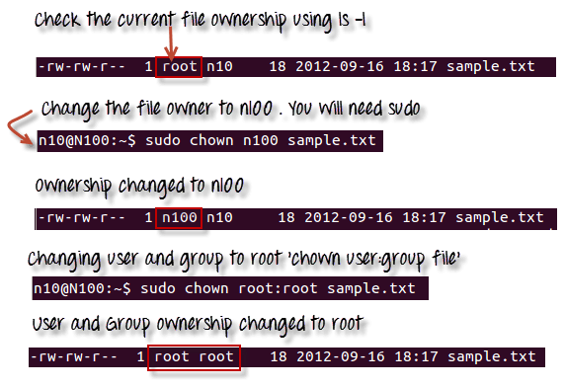

In case you want to change group-owner only, use the command ***chgrp group_name filename***

'**chgrp'** stands for change group.



**Note:**

•

The file /etc/group contains all the groups defined in the

system

•

You

can use the command "groups" to find all the groups

you

are a

member

of

•

You

can use the command newgrp

to work as a member a group

other

than your default

group

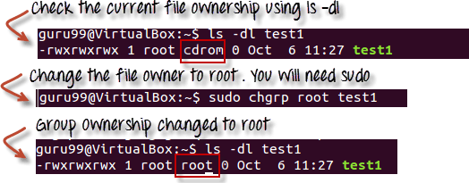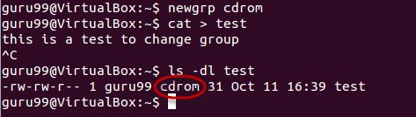

* You cannot have 2 groups owning the same file.
* You do not have nested groups in Linux. One group cannot be sub-group of other
* x- eXecuting a directory means Being allowed to "enter" a dir and gain possible access to sub-dirs

**chage**: command let you specify an expiration limit for a user's account and password .

**Syntax:** chage [option] username

Option

- l lists the current password expiration.

-m set the min. days to change the password. M set the max. days to change the password. E specific expiration date for user account.

-I set inactive period (in days)

-W warning period, number of days before expiration.

**Process management:**

Process is running instance of a program. Process manangement starts with init command which is present in a file named /etc/initta. Init is the first process that runs on the system and can start other processes depending upon the run level. Every process has process idenfication(PID) number. PID of init is 1.

**Different types of process:**

Daemon process

User process

To display currently running processesdon linux system following **ps** command is used.

Output of the ps command has following fields

Column HeaderContents

%CPU How much of the CPU the process is using

%MEM How much memory the process is using

ADDR Memory address of the process

C or CP CPU usage and scheduling information

NI nice value

|  |  |
| --- | --- |
| PID | Process ID number |
| PPID | ID number of the process's parent process |
| PRI | Priority of the process |
| RSS | Real memory usage |
| S or STAT | Process status code |
| START or STIME | Time when the process started |
| SZ | Virtual memory usage |
| TIME | Total CPU usage |
| TT or TTY | Terminal associated with the process |
| UID or USER | Username of the process's owner |
| WCHAN | Memory address of the event the process is waiting for |

To kill process using PID command **kill** is used. And to kill process by name **killall** command is used Job management:

Job management uses the concept of foreground and background processes. Foreground process always have access to the standard input stream to receive command from the user and the standard output stream to print information to the user. Where the programs which run in the background are do not have access to these streams. So can’t interact with user . Compiling and building software related programs can run in background. Through command we can make any program executing in background to run in foreground and vice versa.

**Linux commands for Process Management:**

**ps:** used to list the process.To display a information about process specific to the active terminal.

**Syntax:** ps [option]

Options available:

-a : To display all process, excluding process not controlled by a terminal

-x : To include all process not controlled by a terminal, such as daemon process. -l : To long list including more information such as process owner's user id.

-u : To display user name of the process owner. -e

: To view the all process id

**kill:**  used to send a particular process to get clear.

**Syntax :**

kill -9 <process id>

ps - aux is the command to view all process name and id

Example: kill -9 3743 (This example shows the kill command, option and the process id to kill.)

**Renice:** used to set the priority of a process.The priority value can range from -20 (highestpriority) to 19 (Lowest priority) **Syntax :**

renice - +(minus symbol or plus symbol) <priority number> -p <process id> Example : renice -15 -p 1970

**jobs**  command helps you to view the background processes.

**Fg** command is used to run the background process in the foreground (Front

End)jobs <enter> to view the process running and job numbers fg %2 (job number)

**bg** command is used to resume the suspended command in the back grounded.

________________________________________________________________________

**Activities:** **Activities:**

1. Try out different file management commands. Browse manual pages of the commands and try-out different options of the commands
2. User Administration

Create a two users and assign passwords  

Check for creation of login directory of user account.  

 

See and note down userid, groupid of this user from /etc/passwd file and group

  form /etc/group file  

Delete any one of the two users created above  

Create a new group1 and add user to this group  

   Create three users and add them to a new group2.  

Create a directory and use chgrp to change group of this directory to group2  

 

Now login using first user of group 1and try accessing this directory of group2 note down output  

 

Check group and owner of the file and then change both group and owner of that

  file using chown  

Explore chage command  

3. process management

* explore ps command  
* list all jobs  
* start any new process in background  
* start its execution in foreground  
* suspend execution of this process
* resume its execution in background

**_____________________________________________________________________**

**Results:**

**Students should log the results of these commands in a separated file (Do not use write-ups to log your results) and upload it on the drive shared by the faculty. Use *.txt/.doc/.docx extensions only while saving the file. Do not take snapshots.**

**This file must contain on the top:**

**Name:**

**Roll No.**

**Exp No.**

**Batch:**  **Date:**

kjsce@ubuntu:~$ touch new.txt

kjsce@ubuntu:~$ cat>new.txt

hi, i am aayush

^C

kjsce@ubuntu:~$ cat new.txt

hi, i am aayush

kjsce@ubuntu:~$ cat>>new.txt

hi everyone

^C

kjsce@ubuntu:~$ cat new.txt

hi, i am aayush

hi everyone

kjsce@ubuntu:~$ mkdir abc

kjsce@ubuntu:~$ mkdir -m 777 kmmm

kjsce@ubuntu:~$ ls -l

drwxrwxrwx 2 kjsce kjsce 4096 Sep 12 11:54 kmmm

kjsce@ubuntu:~$ pwd

/home/kjsce

kjsce@ubuntu:~$ cd abc

kjsce@ubuntu:~/abc$ ls -d

.

kjsce@ubuntu:~/abc$ cat>test.txt

apple

^C

kjsce@ubuntu:~/abc$ cat>test1.txt

^C

kjsce@ubuntu:~/abc$ ls -d

.

kjsce@ubuntu:~/abc$ mv test1.txt test2.txt

kjsce@ubuntu:~/abc$ cp test.txt test2.txt

kjsce@ubuntu:~/abc$ cat>>test2.txt

^C

kjsce@ubuntu:~/abc$ sudo su

[sudo] password for kjsce:

root@ubuntu:/home/kjsce/abc# useradd ss

root@ubuntu:/home/kjsce/abc# useradd as

root@ubuntu:/home/kjsce/abc# passwd as

Enter new UNIX password:

Retype new UNIX password:

passwd: password updated successfully

root@ubuntu:/home/kjsce/abc# groupadd as66

root@ubuntu:/home/kjsce/abc# groupmod -n soham66 as66

root@ubuntu:/home/kjsce/abc# adduser bhoirsoham

Adding user `bhoirsoham' ...

Adding new group `bhoirsoham' (1005) ...

Adding new user `bhoirsoham' (1004) with group `bhoirsoham' ...

Creating home directory `/home/bhoirsoham' ...

Copying files from `/etc/skel' ...

Enter new UNIX password:

Retype new UNIX password:

passwd: password updated successfully

Changing the user information for bhoirsoham

Enter the new value, or press ENTER for the default

Full Name []:

Room Number []:

Work Phone []:

Home Phone []:

Other []:

Is the information correct? [Y/n] y

root@ubuntu:/home/kjsce/abc# userdel -r bhoirsoham

userdel: bhoirsoham mail spool (/var/mail/bhoirsoham) not found

root@ubuntu:/home/kjsce/abc# ps -a

PID TTY TIME CMD

3022 pts/4 00:00:00 sudo

3025 pts/4 00:00:00 su

3026 pts/4 00:00:00 bash

3195 pts/4 00:00:00 ps

root@ubuntu:/home/kjsce/abc# ps -x

PID TTY STAT TIME COMMAND

1 ? Ss 0:01 /sbin/init splash

2 ? S 0:00 [kthreadd]

4 ? I< 0:00 [kworker/0:0H]

6 ? I< 0:00 [mm_percpu_wq]

7 ? S 0:00 [ksoftirqd/0]

8 ? I 0:01 [rcu_sched]

9 ? I 0:00 [rcu_bh]

10 ? S 0:00 [migration/0]

11 ? S 0:00 [watchdog/0]

12 ? S 0:00 [cpuhp/0]

13 ? S 0:00 [cpuhp/1]

14 ? S 0:00 [watchdog/1]

15 ? S 0:00 [migration/1]

16 ? S 0:00 [ksoftirqd/1]

18 ? I< 0:00 [kworker/1:0H]

19 ? S 0:00 [cpuhp/2]

20 ? S 0:00 [watchdog/2]

21 ? S 0:00 [migration/2]

22 ? S 0:00 [ksoftirqd/2]

23 ? I 0:00 [kworker/2:0]

24 ? I< 0:00 [kworker/2:0H]

25 ? S 0:00 [cpuhp/3]

26 ? S 0:00 [watchdog/3]

27 ? S 0:00 [migration/3]

28 ? S 0:00 [ksoftirqd/3]

30 ? I< 0:00 [kworker/3:0H]

31 ? S 0:00 [kdevtmpfs]

32 ? I< 0:00 [netns]

33 ? S 0:00 [rcu_tasks_kthre]

34 ? S 0:00 [kauditd]

37 ? S 0:00 [khungtaskd]

38 ? S 0:00 [oom_reaper]

39 ? I< 0:00 [writeback]

40 ? S 0:00 [kcompactd0]

41 ? SN 0:00 [ksmd]

42 ? SN 0:00 [khugepaged]

43 ? I< 0:00 [crypto]

44 ? I< 0:00 [kintegrityd]

45 ? I< 0:00 [kblockd]

47 ? I 0:00 [kworker/3:1]

48 ? I< 0:00 [ata_sff]

49 ? I< 0:00 [md]

50 ? I< 0:00 [edac-poller]

51 ? I< 0:00 [devfreq_wq]

52 ? I< 0:00 [watchdogd]

55 ? S 0:00 [kswapd0]

56 ? I< 0:00 [kworker/u9:0]

57 ? S 0:00 [ecryptfs-kthrea]

99 ? I< 0:00 [kthrotld]

100 ? I< 0:00 [acpi_thermal_pm]

105 ? I< 0:00 [ipv6_addrconf]

114 ? I< 0:00 [kstrp]

131 ? I< 0:00 [charger_manager]

173 ? S 0:00 [scsi_eh_0]

174 ? I< 0:00 [scsi_tmf_0]

175 ? S 0:00 [scsi_eh_1]

176 ? I< 0:00 [scsi_tmf_1]

177 ? S 0:00 [scsi_eh_2]

178 ? I< 0:00 [scsi_tmf_2]

179 ? S 0:00 [scsi_eh_3]

180 ? I< 0:00 [scsi_tmf_3]

182 ? I 0:00 [kworker/u8:3]

184 ? S 0:00 [i915/signal:0]

185 ? S 0:00 [i915/signal:1]

186 ? S 0:00 [i915/signal:2]

196 ? I< 0:00 [kworker/3:1H]

197 ? S 0:00 [scsi_eh_4]

198 ? I< 0:00 [scsi_tmf_4]

199 ? S 0:00 [usb-storage]

226 ? Ss 0:03 mount.ntfs /dev/sda4 /root

235 ? S< 0:01 [loop0]

238 ? I< 0:00 [kworker/1:1H]

239 ? I< 0:00 [kworker/2:1H]

247 ? I< 0:00 [kworker/0:1H]

248 ? S 0:00 [jbd2/loop0-8]

249 ? I< 0:00 [ext4-rsv-conver]

290 ? Ss 0:00 /lib/systemd/systemd-journald

336 ? Ss 0:00 /lib/systemd/systemd-udevd

359 ? S< 0:00 [loop1]

362 ? S< 0:00 [loop2]

627 ? S 0:00 [irq/27-mei_me]

917 ? Ss 0:00 /usr/sbin/acpid

921 ? Ss 0:00 /lib/systemd/systemd-logind

931 ? Ss 0:00 /usr/sbin/cron -f

956 ? Ssl 0:00 /usr/sbin/NetworkManager --no-daemon

957 ? Ssl 0:00 /usr/sbin/thermald --no-daemon --dbus-enable

960 ? Ssl 0:00 /usr/lib/accountsservice/accounts-daemon

961 ? Ssl 0:00 /usr/sbin/ModemManager

964 ? Ssl 0:00 /usr/lib/snapd/snapd

998 ? Ss 0:00 /usr/sbin/irqbalance --pid=/var/run/irqbalance.pid

1008 ? Ssl 0:00 /usr/lib/policykit-1/polkitd --no-debug

1026 ? SLsl 0:00 /usr/sbin/lightdm

1046 tty7 Ssl+ 0:40 /usr/lib/xorg/Xorg -core :0 -seat seat0 -auth /var/ru

1051 ? Ssl 0:00 /usr/bin/python3 /usr/share/unattended-upgrades/unatt

1056 ? Ss 0:00 /usr/sbin/sshd -D

1181 ? Sl 0:00 lightdm --session-child 12 19

1306 ? Ssl 0:00 /usr/lib/upower/upowerd

1588 tty1 Ss+ 0:00 /sbin/agetty --noclear tty1 linux

1942 ? Ssl 0:00 /usr/lib/udisks2/udisksd --no-debug

1988 ? Ssl 0:00 /usr/lib/x86_64-linux-gnu/fwupd/fwupd

2518 ? Ss 0:00 /usr/sbin/cupsd -l

2519 ? Ssl 0:00 /usr/sbin/cups-browsed

2526 ? I 0:00 [kworker/1:2]

2744 ? I 0:00 [kworker/1:0]

2748 ? I 0:00 [kworker/2:1]

2751 ? I 0:00 [kworker/3:0]

2770 ? I 0:00 [kworker/0:1]

2856 ? I 0:00 [kworker/0:0]

2965 ? I 0:00 [kworker/u8:1]

3005 ? R 0:00 [kworker/u8:0]

3022 pts/4 S 0:00 sudo su

3025 pts/4 S 0:00 su

3026 pts/4 S 0:00 bash

3196 pts/4 R+ 0:00 ps -x

root@ubuntu:/home/kjsce/abc# ps -u

USER PID %CPU %MEM VSZ RSS TTY STAT START TIME COMMAND

root 1046 1.0 1.1 432508 96620 tty7 Ssl+ 11:22 0:40 /usr/lib/xorg/X

root 1588 0.0 0.0 15936 1788 tty1 Ss+ 11:22 0:00 /sbin/agetty --

root 3022 0.0 0.0 54792 3880 pts/4 S 12:15 0:00 sudo su

root 3025 0.0 0.0 54376 3584 pts/4 S 12:15 0:00 su

root 3026 0.0 0.0 21224 3824 pts/4 S 12:15 0:00 bash

root 3197 0.0 0.0 37364 3316 pts/4 R+ 12:26 0:00 ps -u

**_____________________________________________________________________**

**Outcomes: CO1:** Understand basic structure of modern operating system

**CO4:**  Demonstrate open source standards usage

**_____________________________________________________________________**

**Conclusion:**

Students must have basic understanding of Linux Operating System.

_____________________________________________________________________

**Grade: AA/AB/BB/BC/CC/CD/DD**

**Signature of faculty in-charge with date**

**_____________________________________________________________________** **References:**

**Books/ Journals/ Websites:**

1. RichardndEdition Blum edition, and Christine Wiley, 2012 Bresnahan, “Linux. Command Line & Shell Scripting”, II